Alphabet names – a learning-rich ice breaker, team activity exploring ‘synergy’

Summarised by Andrew Gibbons

This is what you do...

Get everyone to write the letters A to Z in two columns on A4 paper.

When this is done, decide how many groups to split them into - groups of 4 or 5 are ideal.

There must be at least two groups for this activity. The sample pictures should help clarify.

Once the individual A to Zs have been prepared, do the same, in bigger sized writing on flip
chart, again seeking two columns - maybe A-M and N-Z it doesn’t really matter how many are
in each column, but do make sure each letter is at least 3/4 an inch high. Each small group
will need to plot the 26 letters onto chart.

Next, ask for anyone in the group to read from any page of any printed page. So, a newspaper
would be OK, but it could be anything, so long as they read the first few words of any section.

The idea is to write the first 26 consecutive letters downwards against the letters of the alphabet already plotted on their A4 page – they do this individually first, the charts are for later.

Don’t let on what is happening yet, or the sharp ones will be working on it already.

For the above reason, don’t even tell them the title of the activity.

Anyway, make sure they are all agreed on the precise words and letters - it’s remarkable how long it can take to get consensus on this...some people actually struggle with the alphabet, so be a bit sensitive.

It’s essential that they all have the same combinations of letters as their individual pairs.

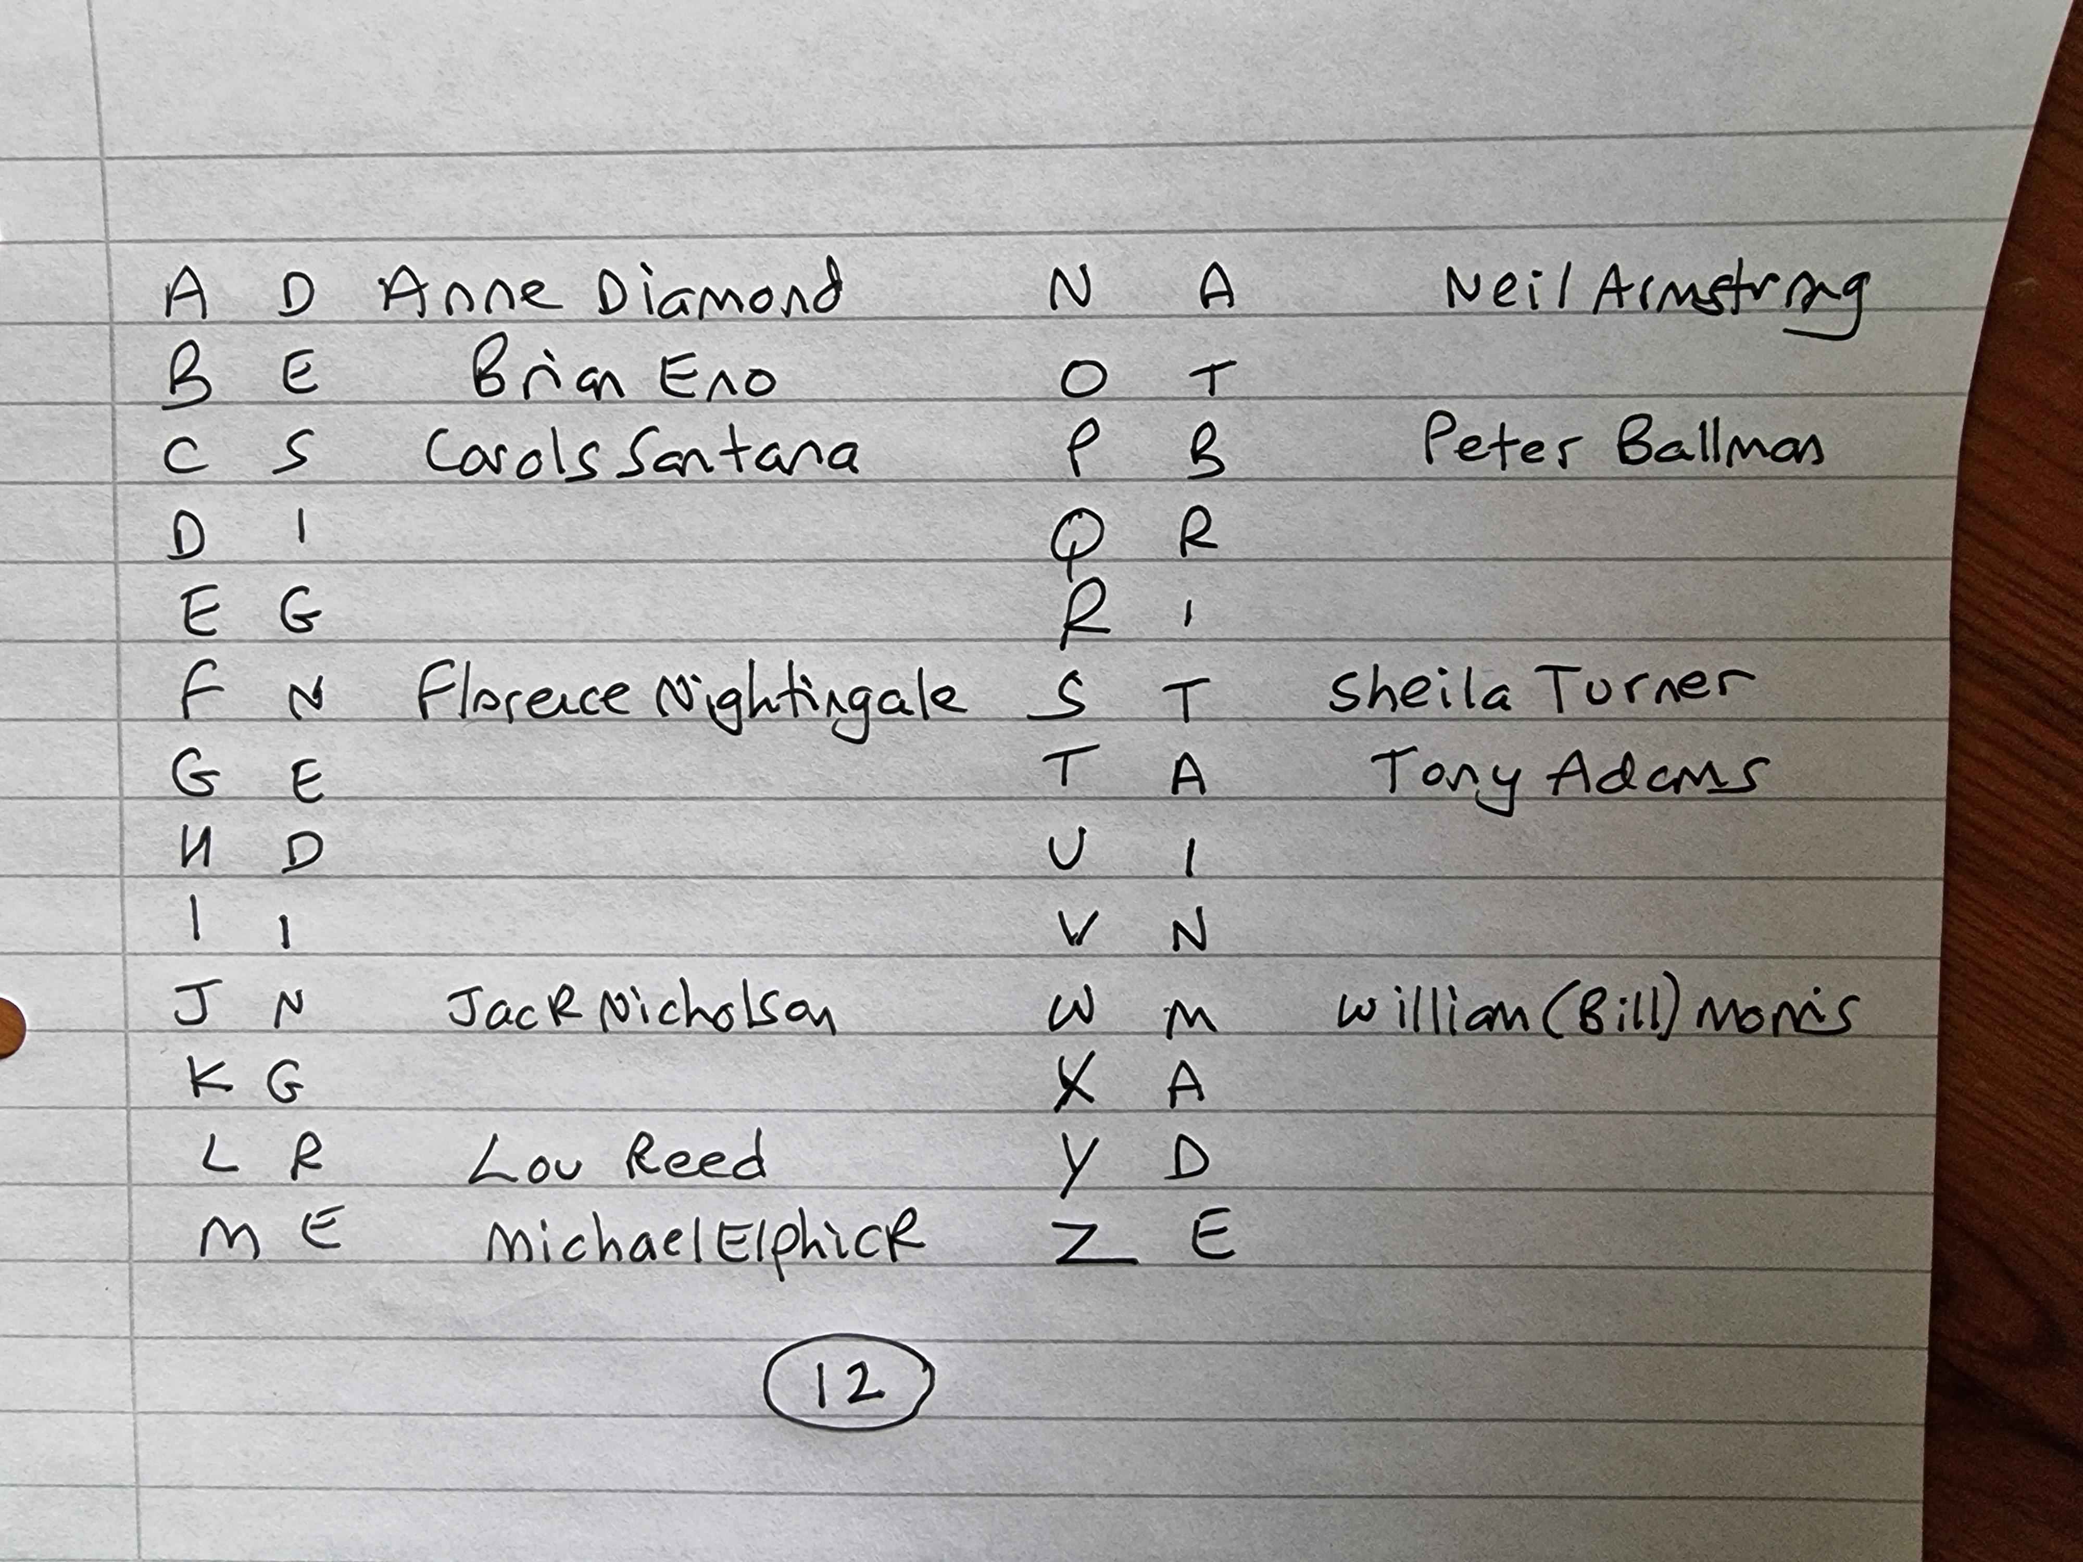

Then, get a different set of 26 consecutive letters from a different source, and do the same for
the flip charted letters. Again, each flip chart must have the same combinations of two letters.

It’s very important that the flip charts are then hidden, or some people may start working on them once they know the purpose of the exercise.

Get them to turn their A4 sheets over so they can’t see them as you explain the task.

Tell them that when you are ready, they will produce as many names from the initials they have
on their A4 sheets. That they should do this as quietly as possible, or they might give some of
their successes away, that it is a competitive activity - we’ll see who can get the most - and that
they have 3 minutes.

Let them know you will give them a one, two and two and a half minute warning. You may also like to count the last ten seconds down.

The more famous or well-known the better, as their claims will be adjudicated. It’s okay to use friends, ex colleagues, people you went to school with, or whatever, but, you must be able to convince your partner in debrief that they are valid, and real – expect some ‘creativity’.

Then off they go.

One the stroke of three minutes they pair or trio off and must convince a colleague of the existence of their claimed people.

Give them no more than two minutes to verify their claims, then take individual scores, and average these for the whole group.

Without delay get them working next on the group, flip charted pairs of letters.

It’s best if they can do this out of earshot of each other, as they will generate noise and
excitement, and this can give some names away.

If you break them up into different rooms, it’s hard to get them all started at the same time.

Again, they have three minutes, and try to let them all know how this is slipping away.

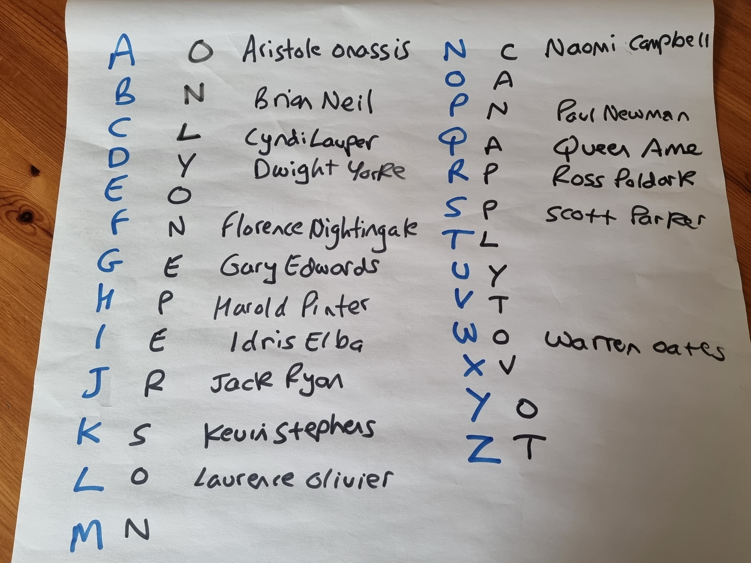

Close them down on three minutes, and alert to cheating - typically by continuing to work on the pairs after time has been called.

Then get each group to present their claimed names to the others, and only allow those passed, if necessary by majority vote.

This is usually a time of some hilarity, noise, and sometimes heated, ‘though good nature disputes.

At the end, take the average of the group-produced names, and hopefully, but not always, it
will show the synergy effect - that the groups produced a better output than the average of the
individual round.

One variation is to have an ‘everyone in one group’ third round to emphasise the learning points, and perhaps show that too many in a group can actually cause less efficiency.

There will be plenty of issues relevant to team working and creativity.

Good luck.

Andrew Gibbons

andrew@andrewgibbons.co.uk

PS: Do get in touch if you I can help clear up anything not immediately clear,

